Solving Green Vehicle Routing Problem Using Heuristic Approach

**Name of the Student: Md. Ahsan Habib, Thesis/Project No:**

**Name of the Supervisor:** Dr. Muhammad Aminul Haque Akhand, Professor, Dept. of CSE

***Abstract:*** **Vehicle Routing Problem (VRP) is the real-life problem faced by manufactory or warehouse authorities who serve their customers from an appointed city and travels some cities in the shortest inferable path. Green Vehicle Routing Problem (GVRP) is a variant of VRP which takes into account polluting emissions constraint in case of conventional vehicles. On the other hand, Alternative Fuel vehicle like Electrical vehicle does not emerge polluting emissions but has limited battery-capacity. So, we consider both Conventional and Electrical vehicles in case of Green Vehicle Routing Problem (GVRP). As a solution, we present a heuristic approach to solve GVRP.**

***Methodology:*** We use three different phases to solve Green Vehicle Routing Problem. They are: Clustering, Route Assignment, Apply Improvement Heuristic. In the beginning, as we discussed two types of vehicles are used to solve GVRP, it is needed two clusters named as C and E which are served by the conventional vehicles and electrical vehicles respectively. In order to create cluster C and cluster E, two scores called PC and PE are used. These scores are calculated based on the customers location/position and demand. They both have range in 1 to 10 (1 <= PC,PE <= 10). After this step, all customers are either assigned to cluster C or cluster E. Then, routes are assigned from cluster C and E separately for conventional vehicles and electrical vehicle. In case of inserting unserved customer into routes, it is necessary to calculate best unserved customer and best position and to verify the capacity constraints and time windows constraints of the new solution. After completing this step, we find an initial feasible solution. And lastly, we apply Local Search (LS) and Perturbation to make the initial solution better. The strategies used by Local Search are described in followings: Change of customer belonging to conventional routes, change of customer belonging to electrical routes, change of customer belonging to the conventional and electrical routes. In case of LS, worsening of the solutions are not accepted. The perturbation is performed by using the same strategies as those in the LS but worsening of the solutions are accepted in order to better explore the neighborhood. For better visualization those strategies are depicted in Fig.1.

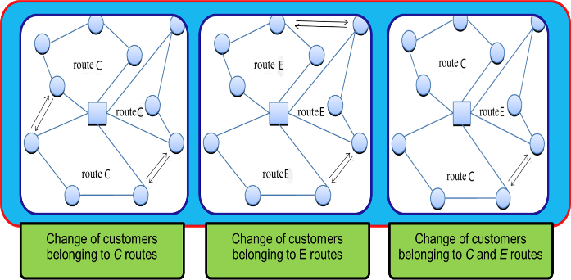

**Fig. 1.** LS strategies.

***Result:*** Here, we show comparison with expected result and optimal result, which is based on modified Solomon, 1987 instances. At first the problems are solved by CPLEX 12.5, an optimization software package, which produce the optimal solution. As CPLEX can only solve the problem with small customer, 5 and 10 customers are considered.

|  |  |  |  |  |
| --- | --- | --- | --- | --- |
| Class | α = 0.25 | | α = 0.50 | |
| Cost Variation (%) | Speed Up | Cost Variation (%) | Speed Up |
| | N | = 5 | 5.25% | 1.46 | 9.32% | 1.05 |
| | N | = 10 | 13.67% | 12.81 | 12.93% | 8.96 |
| Average | 9.46% | 7.13 | 11.13% | 5.01 |

***Future Work:*** We will use hybrid vehicles (conventional and electrical engine) and bi-fuel vehicles (gasoline and CNG/LPG/Hydrogen) to solve GVRP. We will minimize the cost and emissions using the algorithms more efficiently.

***Conclusion:*** Although GVRP is NP-hard optimization problem, we solved it efficiently through heuristic approach. Also, by using the proposed heuristic, many real-world and large-scale problem can be solved efficiently.

***Reference Paper:*** G. Macrina, P. Pugliese, F. Guerriero and G. Laporte, *The green mixed fleet vehicle routing problem with partial battery recharging and time windows,* Computers and Operations Research 101 (2019), pp. 183–199.